Assessment Schedule – 2012

Science: Demonstrate understanding of aspects of mechanics (90940)

Evidence Statement
Question | Evidence |  |  | Achievement |  | Merit |  | Excellence
ONE  (a) | 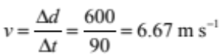 (rounding ignored) |  |  | - Calculates average speed.
(b) | During section B the tractor is moving at a constant speed. This means that the forces acting are balanced. This means that they are equal and opposite.  Not forces are equal – but can be forces are equal sizes with opposite direction. |  |  | - Correct statement.  Eg:  States that tractor has constant speed in section B.  OR  States forces are balanced in section B.  OR  Net force = 0. |  | - Explains motion of tractor in section B in terms of forces.  (either used term balanced or net force = 0)
(c) | Slope of section B = speed of tractor at end of section A = rise/run = 480 / 60 = 8 m s^{–1}  a = Δv / Δt = (8 – 0) / 30 = 0.27 m s^{–2}  F = ma = 1660 × 0.27 = 448.2 N  (or 443N without immature rounding)  Alternative working for finding speed at end of section A, and acceleration.  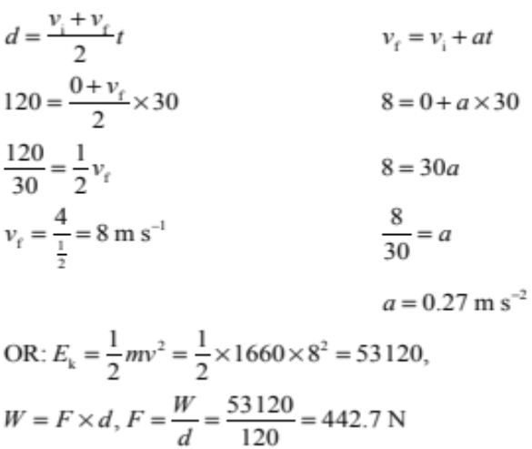 |  |  | - States slope of graph in section B = speed at end of section A.  OR  Calculates speed at end of section A.  OR  Calculated acceleration with wrong speed  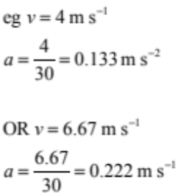  OR  Calculated E_{k} = 53 120 J |  | - Calculates acceleration correctly.  OR  Force calculated consistently using incorrectly calculated acceleration.  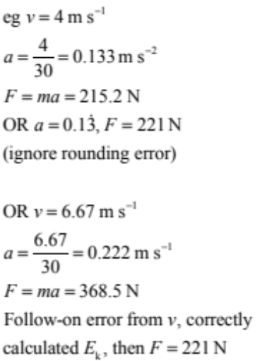 |  | - Calculates net force during section A.  Only two possible answers:  F = 442.8 N or 443 N  (ignore rounding)
(d) | The car’s tread pattern has a greater surface area in contact with the ground than the tractor.  The car’s weight force (F = mg) will be less than the tractor’s.  Since P = F/A, a smaller force divided by a larger surface area will lead to less pressure exerted on the ground than the tractor. Whereas the tractor having a larger force divided by a smaller area will apply far more pressure on the ground causing it to sink more.  On the beach grip / traction is achieved by sinking into the sand.  As the car applies a smaller amount of pressure on the sand it will not sink in therefore giving it less grip / traction and as a result it gets stuck in sand. |  |  | - Correct statement about either force, surface area or pressure of either tyre.  (A smaller surface area gives bigger pressure on the tractor tread.) |  | - Explains why tractor tyre exerts a greater pressure on ground leads to digging in the sand therefore more traction.  OR  Compares and contrasts car and tractor tyres in terms of surface area and pressure or weight force and pressure.  (Just compared surface area and force if not enough for Merit.) |  | - Explains why the car gets stuck in the sand whereas the tractor does not in terms of (force), surface area and pressure.  (If a student did not say the weight force for tractor is bigger than the car, but said the same weight, accept as correct.)  (Mentioned force is a factor of pressure; no comparison required.)  Must clearly link how surface area affected the pressure then grip / traction / friction force which enable the tractor not to get stuck.
 | Not Achieved |  |  | Achievement |  | Achievement with Merit |  | Achievement with Excellence
Q1 | NØ – no response or no relevant evidence | N1 – correct idea. | N2 = 1 point | A3 – 2 points | A4 – 3 points | M5 – 2 points | M6 – 3 points | E7 1 points | E8 – 2 points (allow one minor error in one point)

Question | Evidence |  |  | Achievement |  | Merit |  | Excellence
TWO  (a) | Sam has the greater acceleration during the first 2 seconds.  The gradient / slope of a speed-time graph equals the acceleration of the object. The steeper the slope the greater the acceleration. Sam has a steeper slope than Tama in the first 2 seconds. |  |  | - Correct statement.  Eg:  Sam has greater acceleration.  OR  Slope of speed-time graph  = acceleration. |  | - Explains why Sam has greater acceleration in terms of slope (gradient, angle of the path on the graph or change in speed).  Eg, Sam’s speed changed from 0 to 9 while Tama from 0 to 4 ( in 2 s)  (NOT distance)
(b) | To calculate work done:  a = slope = 9/2 = 4.5 m s^{–2}  F = ma = 60 × 4.5 = 270 N  W/E = F × d = 270 × 9 = 2430 J  OR  E_{k} = ½mv² = ½ × 60 × 9² = 2430 J |  |  | - Calculates acceleration.  OR  Writes:  E_{k} = ½mv² = ½ × 60 × 9²  Without answer, or wrong answer |  | - Correct calculation of Force  OR  Correct methods and working but wrong answer for work done. (Possible follow-on error from calculating acceleration.) |  | - Calculates work done.
(c)(i)  (ii) | Sam accelerates at 4.5 m s^{–2} for 2 seconds, reaching a speed of 9 m s^{–1}. Stays at constant speed of 9 m s^{–1} for next  8 seconds.  Tama accelerates at 2 m s^{–2} for 5 seconds, reaching a constant speed of 10 m s^{–1}. Stays at constant speed of  10 m s^{–1} for next 5 seconds.  Comparison: Sam has a greater acceleration during first  2 seconds, but does not accelerate for as long as Tama. Between 5 and 10 seconds, neither accelerated, they both had a constant speed. Tama had a higher constant speed during this time.  Distance = area under graph.  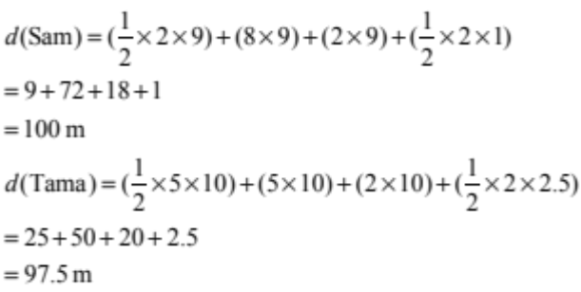  Therefore only Sam has finished the race. |  |  | - Correct statement / calculation.  ie  Correct statement about speed.  OR  Correct working and answer for average speed.  OR  Correct statement about acceleration.  OR  Correct working and answer for average acceleration.  OR  Sam’s average speed =8.1m⁻¹  Over 10s  OR  Tama’s average speed =7.5 ms⁻¹  over 10s  - Calculates a correct distance under the graph for any part of either Sam or Tama’s journey (usually on graph). |  | - Correct statement about speed with justification from graph.  OR  Correct statement about acceleration with justification from graph.  OR  Two cells either horizontally or vertically.  OR the bold 4 for merit.  - Correct calculation of distance for one of the two runners for 12 s. |  | - Shows Sam finished the race (first) at 12 s using calculations.  (Area under graph at 12 s;  Sam = 100 m, Tama = 97.5 m calculated.)  Minor error can occur but have to end up with correct conclusion  Eg, Sam finishes first.  Distance for Sam = 101 m (OMI*)  and for Tama = 97.5 m  OMI*: One Minor error Ignored
   | Speed | Acceleration
  Sam | First 2 s:  = 4.5 m s^{–1}  The rest:  v = 9 m s^{–1} | First 2 s:  a = 4.5 m s^{–2}  The rest:  a = 0 m s^{–2}
  Tama | First 5 s:  = 5 m s^{–1}  The rest:  v = 10 m s^{–1} | First 5 s:  a = 2 m s^{–2}  The rest:  a = 0 m s^{–2}
 | Not Achieved |  |  | Achievement |  | Achievement with Merit |  | Achievement with Excellence
Q2 | NØ – no response or no relevant evidence | N1 – correct idea. Eg, correct unit or correct use of formula | N2 – 1 point | A3 – 2 points | A4 – 3 points | M5 – 2 points | M6 – 3 points | E7 – 2 points with minor error in one point | E8 – 2 points

Question | Evidence | Achievement | Merit | Excellence
THREE  (a) | Weight of golf ball:  F_{net} = ma = 0.046 × 10 = 0.46 N | - Calculates weight force.
(b)  OR | Pressure:  How far the balls sink into the flour is determined by the pressure they exert on the surface when they land.  Pressure = force / surface area  The golf ball has a greater mass than the table-tennis ball which means that its weight force (F = mg) will be higher (F_{golf ball} = 0.046 × 10 = 0.46 N,  F_{table-tennis} = 0.003 × 10 = 0.03 N).  As pressure is directly proportional to force, the golf ball will exert more pressure on the ground therefore sink in more. | - Correct statement / calculation.  Eg:  Pressure is proportional to force.  OR  Golf ball exerts more pressure.  OR  Calculates weight force of table-tennis ball. | - Explains why golf ball has a greater force, ie identical shape, but golf ball has greater mass therefore greater (weight) force exerted.  OR  - F----P----Crater | - Explains in terms of pressure, why the golf ball creates a deeper crater even though they are the same size and shape. Golf ball has greater weight force. Both balls are same shape so golf ball exerts greater pressure.
(b)  OR | Energy:  Both ball at the same height, but golf ball has bigger mass therefore bigger gravitational energy than the tennis ball. When it falls to the ground, all the gravitational energy converted to kinetic energy. Because golf ball has bigger kinetic energy when hits the ground, it creates bigger impact, therefore deeper crater. | - Golf ball has more gravitational energy than tennis ball at 2 m height.  OR  Golf ball has bigger kinetic energy when it hits the ground. | - More mass leads to more gravitational energy.  OR  The bigger the kinetic energy (due to bigger mass, NOT speed) hits the ground the deeper the crater. | - Explains in terms of mass; leads to bigger gravitational energy therefore bigger kinetic energy and so deeper crater.
(c) | Assuming conservation of energy  E_{p} lost = E_{k} gained  mgh = ½mv²  0.046 × 10 × 2 = ½ × 0.046 × v²  0.92 = 0.023 v²  0.92 / 0.023 = v²  40 = v² v = √40 = 6.32 m s^{–1} | - Calculates E_{p}.  OR  States E_{p} = E_{k} but unable to carry through calculation. | - Correct methods and working but wrong answer for work done due to minor error. | - Calculates speed of golf ball when it hits the flour.

 | Not Achieved |  |  | Achievement |  | Achievement with Merit |  | Achievement with Excellence
Q3 | N0 – no response or no relevant evidence | N1 – correct idea. Eg. correct unit or correct use of formula | N2 – 1 point | A3 – 2 points | A4 – 3 points | M5 – 1 points | M6 – 2 points | E7 – 1 points | E8 – 2 points  Full explanation and fully correct calculation.
Question | Evidence |  |  | Achievement |  | Merit |  | Excellence

FOUR  (a) | W = Fd = 100 × 6 = 600 J |  |  | - Calculates work done.
(b) | Type of energy at top is gravitational potential energy  E_{p} = mgh = 55 × 10 × 1 = 550 J  Energy difference = 600 – 550 = 50 J  More energy is used to get up the ramp as some of the energy is being converted into heat (and sound), due to friction between the wheels and ramp, or the buggy’s moving parts. |  |  | - Correct statement / calculation.  Eg  Identifies type of energy as E_{p}.  OR  Correct calculation for E_{p}.  OR  Energy converted into heat (and sound). |  | - Explains where ‘missing energy’ has gone.  OR  Calculates energy difference. |  | - Correct answer for difference in energy plus states what happens to the difference.  (Must explain where the friction occurred. Accept heat lost due to friction in the muscle.)
(c) | As the height above the ground is always the same, the same amount of work is required to travel up the ramp as lifting the buggy straight up. As W = F × d, if d is increased, the amount of force required to do the same amount of work will be less, making it easier to push up the ramp. In other words a long ramp allows the same amount of work to be done with a smaller force over a greater distance.  Can be shown by calculation, eg, to lift straight up, force has to be greater than weight of buggy, which is F = 55 × 10 = 550 N, whereas force used to push it up the ramp was only 100 N.  Then relates difference in force to difference in work done.  OR  When going up the ramp, the push force required is against a component of the gravity force of the child and buggy. A vertical lift would require a push equal to the gravity force.  The energy gained by the buggy is the same in both cases, but the time taken to go up the ramp would be much greater than lifting vertically. As P = E / t, a greater time would mean less power is required. |  |  | - Correct statement.  Eg, same amount of work done regardless of length.  OR  Less force is need to push up the ramp or more force to lift up  (can be with calculations).  (NOT just longer distance on the ramp.)  OR  Less power is needed to push up the ramp (NOT less energy).  OR  More time spend to push up the ramp (vice versa). |  | - Explains that longer ramp allows same / similar amount of work with smaller force.  OR  Less power needed to push up the ramp as it takes longer.  OR  It is easier as the work is spread over a longer time  OR  More power needed to lift as energy is used all at once |  | - Explains why a longer ramp is easier to use than lifting straight up (must show a comparison in terms of force and energy).  Eg, less force needed due to longer distance on the ramp.  OR  Less power due to the longer time on the ramp.
 | Not Achieved |  |  | Achievement |  | Achievement with Merit |  | Achievement with Excellence
Q4 | NØ – no response or no relevant evidence | N1 – correct idea. Eg correct unit or  correct use of formula | N2 – 1 point | A3 – 2 points | A4 – 3 points | M5 – 1 points | M6 – 2 points | E7 – 1 point | E8 – 2 points

Judgement Statement
 | Not Achieved | Achievement | Achievement  with Merit | Achievement  with Excellence
Score range | 0 – 10 | 11 – 18 | 19 – 24 | 25 – 32

